What is P2P Cycle? - SAP Procure-To-Pay Cycle 12 Steps

Every business needs a good procurement process to achieve profitability. This article discusses each step of the procure-to-pay process.
Contents
What is P2P Cycle? - SAP Procure-To-Pay Cycle 12 Steps 1
What is P2P procedure? 1
Procure to pay process 2
1. Requirement Identification 2
2. Authorizing the purchase order 2
3. Purchase order approval 3
4. Shortlisting the vendors 3
5. Taking quotations from the vendors 3
6. Vendor selection 3
7. Shipment notice 3
8. Receiving the goods 3
9. Recording the invoice 4
10. 3 Way Match 4
11. Making a payment to the supplier 4
12. Reporting 4
Advantages of procure-to-pay cycle 4
How do you improve the procure-to-pay cycle? 6
What is procure-to-pay software? 6
Automating P2P Cycle 6
Parameters to select the software for procure-to-pay cycle 7
List of procure-to-pay software vendors 7
What are the challenges of a procure-to-pay cycle? 7
Consolidating the system and process 8
Absence of authority and compliance 8
Unconcern by management 8
Absence of adoption 8
Lack of communication 9
How to deal with the challenges? 9
Automate the process 9
Consider the user experiences 9
Think of proper design 10
Adopt cloud system 10
Keep the process flexible 10
Conclusion 10

What is P2P procedure?
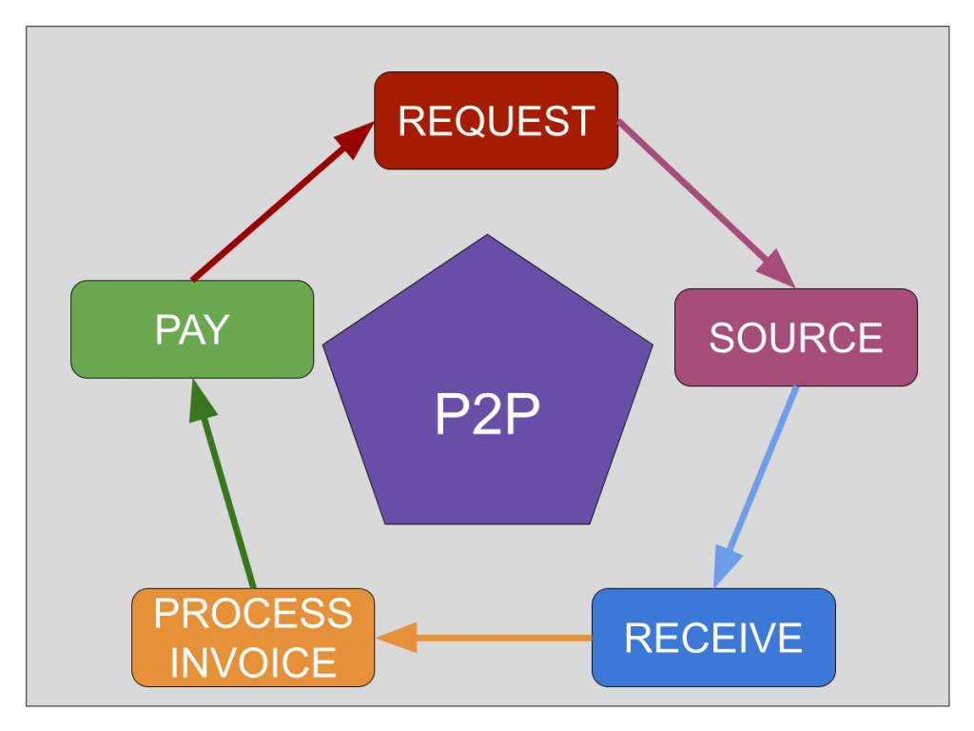
The procure-to-pay cycle (P2P) is the business process activities taken while creating and accepting a purchase order and payment for the items or services.
The procure-to-pay cycle is also known as the purchase-to-pay cycle, often abbreviated as P2P. In this post, we are using those terms interchangeably.
A well-followed Purchase-to-pay cycle helps organizations to maintain good buying practices.
All modern ERP systems, including SAP, maintains good P2P process automation functionalities.
In this post, procure to pay cycle in SAP MM is taken as a reference.

Procure to pay process
The following diagram shows the different steps involved in the procure-to-pay cycle.
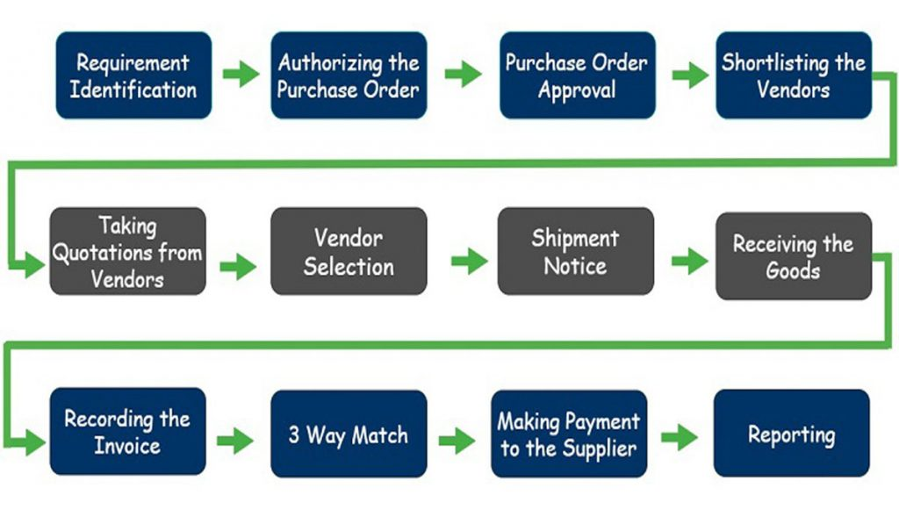
The process of Procure-to-Pay or P2P starts when a buyer finds a need for some goods or services.

1. Requirement Identification
This is the first step in the procure-to-pay cycle.
Whenever there is a shortage of raw materials or services or any parts needed to continue the operation, the person in charge will identify the material's need or benefit.
The material or service's need is then informed to the purchasing department by creating a purchase request.
The purchase request will be submitted to the purchasing manager.

2. Authorizing the purchase order
The purchasing manager evaluates the purchase order received.
Depending on the importance and cost of the material or the service, it will be sent to the senior-level executives for revision.
Here the purchase order can either be approved or rejected.

3. Purchase order approval
Suppose the purchase manager gets approval from his seniors. In that case, he will authorize the purchase order and send the PO to the procurement department.
The procurement department checks the request form to understand the requirement.

4. Shortlisting the vendors
Depending on the type of the request, either a new list of vendors will be shortlisted, or the procurement department may directly approach the existing vendor for the material.
Shortlisting of the vendors depends on their credibility, vendor rating, quality of the product or service, and pricing.

5. Taking quotations from the vendors
Here the buyer sends RFPs to all the shortlisted vendors to explain the requirements. The vendors are then asked to give their quotations.

6. Vendor selection
Here the vendor responses to the RFP are evaluated, terms and quotations are negotiated with the vendors.
The vendor whose quotation and the buyer accepts terms are shortlisted, and the agreement will be signed.

7. Shipment notice
Once the agreement is signed and the PO is confirmed, the vendor sends the shipment notification to the buyer. Notice informing about the goods or services that they are providing.
At this point, we are halfway through the procure-to-pay cycle. The shipment notice includes all the details like a description of the goods, Shipment date.

8. Receiving the goods
The company receives the goods from the supplier. The materials or services obtained are inspected to check the quality of the materials.
The delivery team compares the PO with the shipment notice to validate if the two match. If they match, the company issues the receipt to the vendor.
But if there are discrepancies, the company can contact the vendor and ask for a refund or replacement.

9. Recording the invoice
After receiving the receipt from the company, the supplier sends them the invoice for payment. The invoice will have all payment details related to the goods delivered.

10. 3 Way Match
Once the invoice is received from the vendor, all the related documents like purchase order and shipment notice have to be reviewed by the company's accounting department.

11. Making a payment to the supplier
Suppose the account payable department finds the match between all the documents regarding price, quantity, and terms and conditions. In that case, the payment will be made to the vendor as per the agreed terms.

12. Reporting
Once the vendor makes the payment, the complete process is documented, and reports are created.

Advantages of procure-to-pay cycle
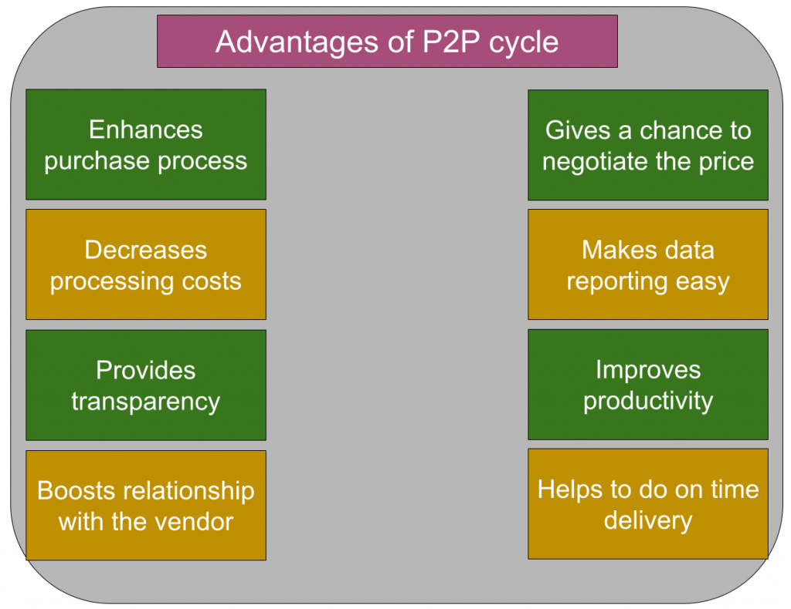
The purchase-to-pay cycle helps your business grow with the following advantages.
Enhances purchase process: The procure-to-pay cycle clearly defines the steps involved in the purchasing procedure. Hence it boosts the overall efficiency of the purchasing process.
Decreases processing costs: ERP purchasing module helps decrease the purchasing procedure's processing cost by providing inventory tracking without paperwork.
Its online ordering ability helps the user to tune the stock levels as soon as orders are acquired.
Provides transparency: The purchase-to-pay cycle helps the purchasing people and the vendors to see where the requisition is. In this way, it brings and boosts visibility into the supply chain.
Boosts relationship with the vendor: The purchase-to-pay process makes sure that the orders are made precisely and payments for the vendors are correctly created.
It also allows the vendors and buyers to communicate and collaborate easily to solve disputes quickly. These essential things lead to improving the relationship with the vendor.
Gives a chance to negotiate the price: Since it improves the relationship with the vendor, buyers can ask for negotiating the price and contracting terms.
Makes data reporting easy: When you have a cloud-based inventory management system, you can easily retrieve real-time reports such as profitability reports, cost reports, and waste reports.
This information allows the managers to have a complete hold over their cash flow and make proper purchasing decisions.
Improves productivity: As it optimizes the purchase process, that helps to improve productivity.
Helps to do on-time delivery: When productivity improves, you will deliver the product or services on time.

How do you improve the procure-to-pay cycle?
By following the below practices, you can improve your purchase-to-pay process.
- Retain the transparency of the process
- Implement the best software for purchase to pay
- Boost the supplier engagement
- Have well-organized contract management
- Enhance inventories

What is procure-to-pay software?
Procure-to-pay software is a technology that automates the complete procure-to-pay cycle and allows the user to control each step of the process. In addition, it will enable the flow of information from the purchasing department to the account payable department efficiently.

Automating P2P Cycle
The purchase-to-pay cycle involves many departments of the organization, as well as many vendors.
Since it is a long process involving a lot of paperwork and administrative tasks, it demands a lot of money and time.
By automating the P2P cycle, organizations can optimize the entire process with the help of technology.
Decreased paperwork and human interference by automating the P2P process help companies reduce operational costs.

Parameters to select the software for procure-to-pay cycle
You need to choose the best technology for the P2P process. While selecting the software, consider the following parameters.
- Speed of the software: Select the application that operates fast so that it helps to reduce the time taken for the process and lessen the team strength.
- The flexibility of the software: Choose the application that can fulfill all your business needs and follow the business rules. The software should be upgradable to the new version and easily customizable according to your needs.
- Transparency: The application should give good insights to do your work. It should allow you to have the correct information to reduce follow-ups both inside and outside of the company.
- Even sharing tasks: Make sure that your software shares the task equally amongst your team members. The software should have the capability to send requisitions automatically to the vendor depending on past purchase history.
- Vendor communication: The application should help you communicate with your vendors, and it should also allow the vendors to check the invoices, quote approvals, payments by themselves.

List of procure-to-pay software vendors
Many vendors are providing the software in the market. I am listing a few best vendors.
- SAP Ariba
  - It provides simple, speedy, and user-friendly technology.
  - It integrates effectively with other ERP systems.
  - It offers flexible processes with budget checking and approval management.
  - It provides absolute receipt and reunion process.
- GEP Smart
  - It is built by expertise in the procurement process.
  - It provides comprehensive technology for the direct and indirect procurement processes.
  - It provides a cloud platform with unified upstream sourcing and downstream procurement process.
- Coupa BSM platform
  - It provides software that has complete visibility and holds on to the procurement process.
  - It provides a modern design experience.

What are the challenges of a procure-to-pay cycle?
While processing purchase-to-pay, an organization faces many problems. Here I am going to list out those challenges.
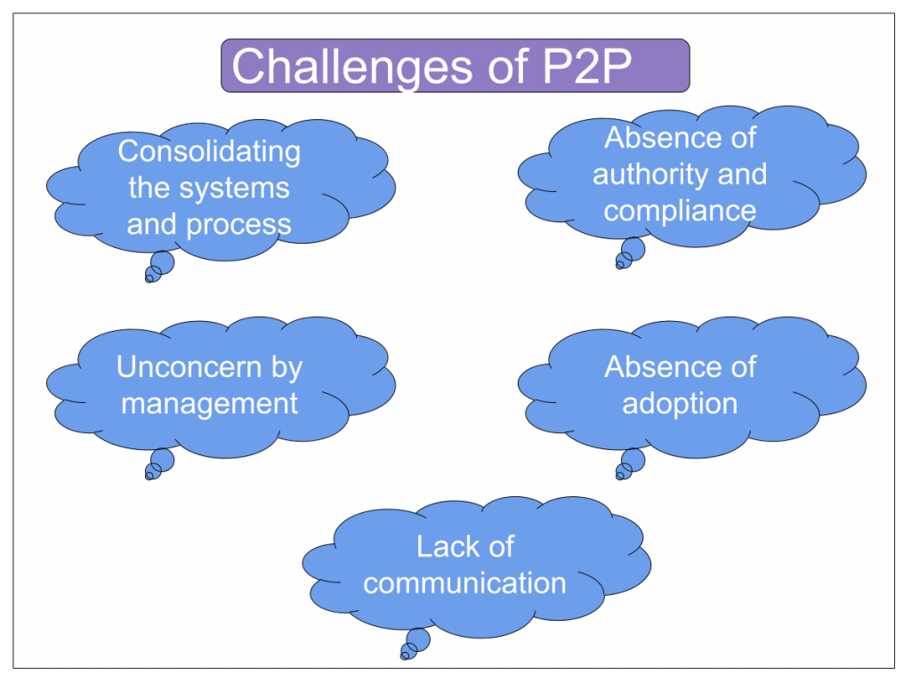

Consolidating the system and process
You know that an organization has many departments, and each department will have its systems and tools. That makes the integration of data difficult.

Absence of authority and compliance
Usually, governance and compliance affect the flexibility of the procuring process.

Unconcern by management
Generally, management thinks that purchasing process is not a critical process. So, the management gives less priority to enhancing the process with upgraded technologies.

Absence of adoption
Typically, A person who knows much more about purchasing and its complexities designs procurement tools or software.
Hence the software will be completely focused on its features, not on usability. So sometimes, users may find difficulty while using the procurement system.
Users do not have enough training to use the system properly. Because of all these issues, several businesses will not show interest in adopting Purchase-to-pay technology.

Lack of communication
In many organizations, changes done throughout the organization will not be communicating with the users or staff. So sometimes, the organization will fail to choose the right procurement software for it.
Hence the chosen technology will not meet and satisfy the user requirements. Moreover, it affects the quality and on-time delivery of the output.

How to deal with the challenges?
Following are a few suggestions to deal with the above challenges faced by the purchase-to-pay cycle process.

Automate the process
It is the best idea to automate the whole purchase-to-pay process. It helps to increase efficiency and decrease the process cost.
Conversion of purchase requisition into purchase order will be done automatically.
The approval process, invoicing, and other processes take place without any complications and interruptions. It is suitable for both vendors and the organization.
This automated system allows the purchasing team to concentrate on more valuable works. It also enables the account payable department to increase productivity and decrease expenses.
The technology pays the vendor on time. Hence there is no risk of late payment. It helps to bond the customer and supplier with a good bond.
Because of the early payment, you may also get some discounts, which also helps reduce the cost.

Consider the user experiences
Automating the process becomes successful and worthy only when it serves its purpose. Therefore, it should be helpful and easy to use for the employees.
If the employees find it difficult while using the system or technology, there is no use in implementing the automated process.
Hence while implementing a new system, consider the employees' or users' experience.

Think of proper design
Adopt a worker-centric method to design the procurement process. It helps to develop a system that considers user and usability. It will be easy to use for the worker as time goes.

Adopt cloud system
You know that for an organization, master data security is much more important. Cloud technology helps the organization to standardize the business process.
It enhances efficiency and reduces process expenses. It also allows the organization to change the system rapidly and efficiently.

Keep the process flexible
In the old purchase process, the process was done only in-house with one or two devices.
Nowadays, employees are started asking the access anywhere, any time with regardless of devices.
So it allows the employee to work anywhere and anytime and hence enhances the procure-to-pay process at full speed.

Conclusion
Future technology could be the blockchain in procure-to-pay to enhance transparency.
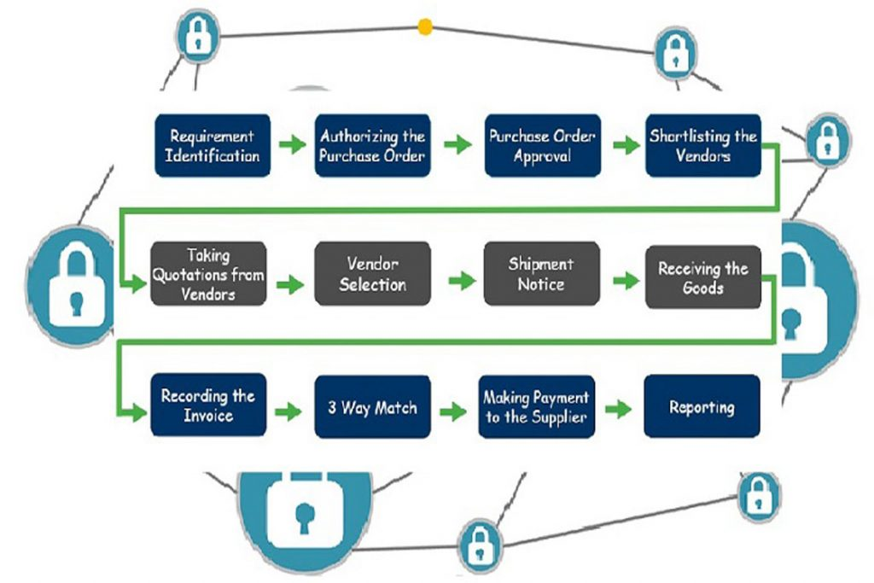
The blockchain is an open, distributed ledger that can record activities between two parties in a verifiable and unchanging way.
Companies of all sizes need to look into the purchase-to-pay cycle to improve business performance keenly.
Not just SAP MM, procure to pay cycle in Oracle apps, PeopleSoft, and similar enterprise software solutions provide P2P functionalities.

