Master Production Schedule (MPS) - A Comprehensive Guide

Master Production Schedule (MPS) - A Comprehensive Guide 1
Definition of Master Production Schedule 2
Importance of Master Production Schedule(MPS) 3
Inputs to MPS 4
Different methodologies for Master Production Scheduling 5
Make to Stock Environments 6
Make-to-Order or Build-to-Order Environments 7
Assemble-to-Order Environments 7
Benefits of Master Production Schedule 7
Functions of Master Production Scheduling (MPS) 8
Transforming Plans 8
Provide Alternative Production Routes 8
Utilization of Available Resources 9
Establish Capacity Requirement 9
Aid in Information Processing 9
Master Production Schedule Example 9
Seven proven steps for creating great MPS 10
Three tips for creating master production schedule 11
Create a realistic master production schedule 11
Start with your high-priority items 11
Break down each task into smaller steps 12
FAQs 12
How is production planning different from the master production schedule? 12
What is meant by master scheduling? 12
Conclusion 13

Master Production Schedule (MPS) is a critical tool for manufacturers.
It helps ensure that the right products are made at the right time and in the right quantities.
This article will answer questions on MPS, its functions, and its benefits. Keep reading to learn more about it and how it can benefit your organization.

Definition of Master Production Schedule
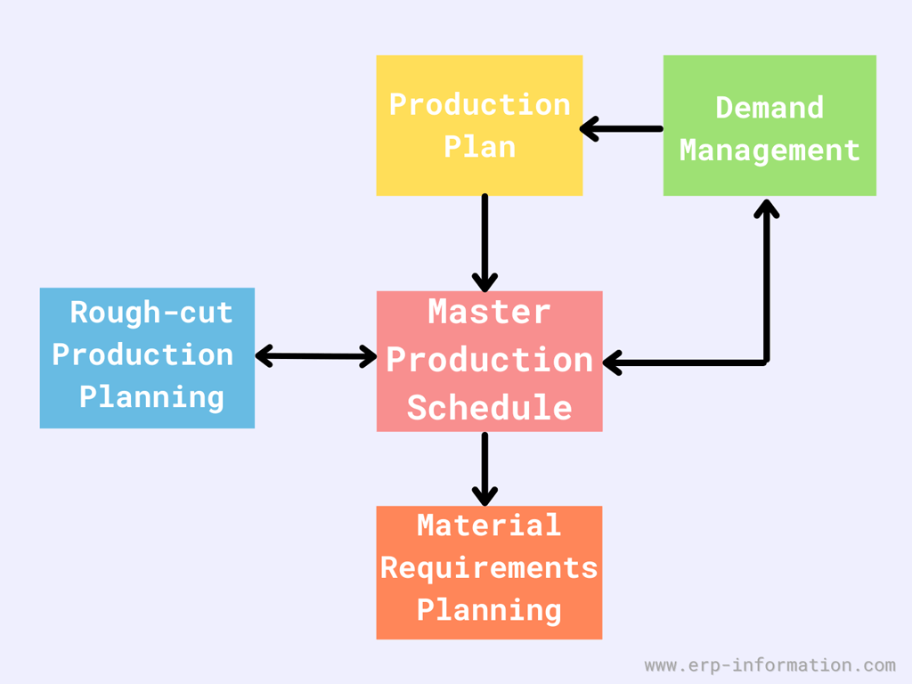
Master Production, as the name suggests, decides what products need manufacturing and the accurate time to manufacture that product.
Master Production Scheduling (MPS) is a process in manufacturing to decide which products to produce and how much quantity is required to meet the requirement in a given interval of time.
It can be used in any industry where a good deal of production is necessary, such as manufacturing, construction, and logistics.
There are many different versions of it, but all achieve the same goal: creating a plan that allocates resources to deliver products or services on time and at the lowest possible cost.
This production planning tool helps companies manage their finite resources to produce the greatest possible output. As a result, companies using MPS report improved efficiency, reduced waste, and increased customer satisfaction.
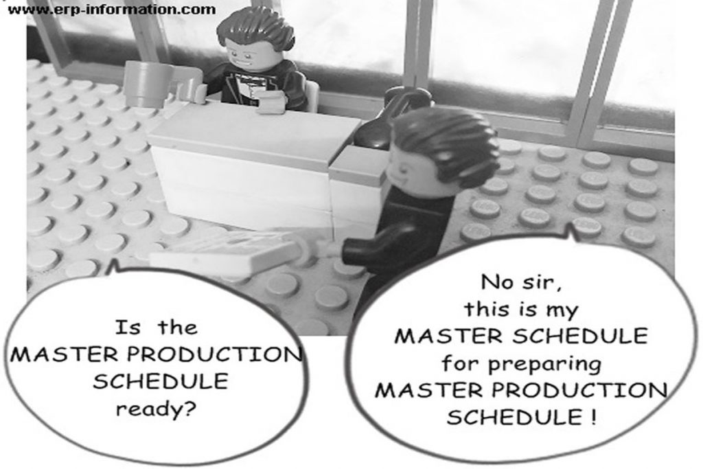
Bill of Materials (BOM) and Material Requirements Planning (MRP) are the two crucial aspects.
The Bill of Materials BOM then identifies the raw materials required to produce finishing goods.

Importance of Master Production Schedule(MPS)
MPS is an integral part of an Enterprise Resource Planning system. It provides the most effective planning functionality by extracting the actual demand and supply data to deliver precise production plans.
These plans assist manufacturers in quickly achieving their production goals and minimize the cost incurred on the procurement.
While performing calculations of operating expenses, it pays special heed to the manufacturing capacity of the production plant.
Automatic initiation of Material Resource Planning management process and generation of the purchase order takes place soon after the analysis and the approval of the production orders.
Aside from all these implications, it acts as a protective barrier against shortages, unexpected scheduling snafus, and inefficient allocation of resources.

Inputs to MPS
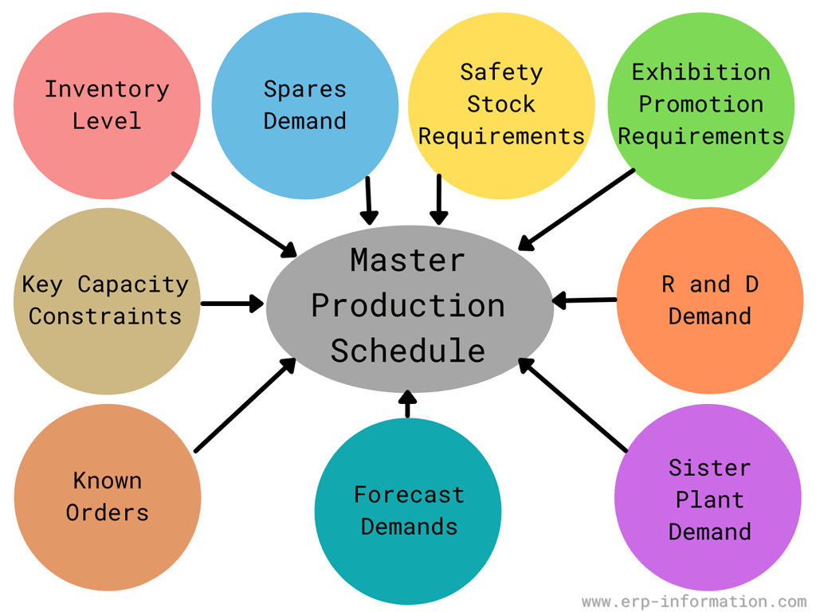
Following are the list of inputs,
- Forecast demands
- Known orders
- Key capacity constraints
- Inventory level
- Spares demand
- Safety stock requirements
- Exhibition promotion requirements
- R & D demands
- Sister plant demand

Different methodologies for Master Production Scheduling
The Master Production Schedule needs to devise a final plan for manufacturing using all the currently available resources.
If the MPS emphasizes too many items, then the plan proposed by MPS does not apply to the manufacturers.
Apart from that, the production capacity suffers if the plan proposed by MPS isn’t detailed enough.
As a general rule of thumb, master scheduling is only applicable in the particular case where the smallest number of product alternatives are available.
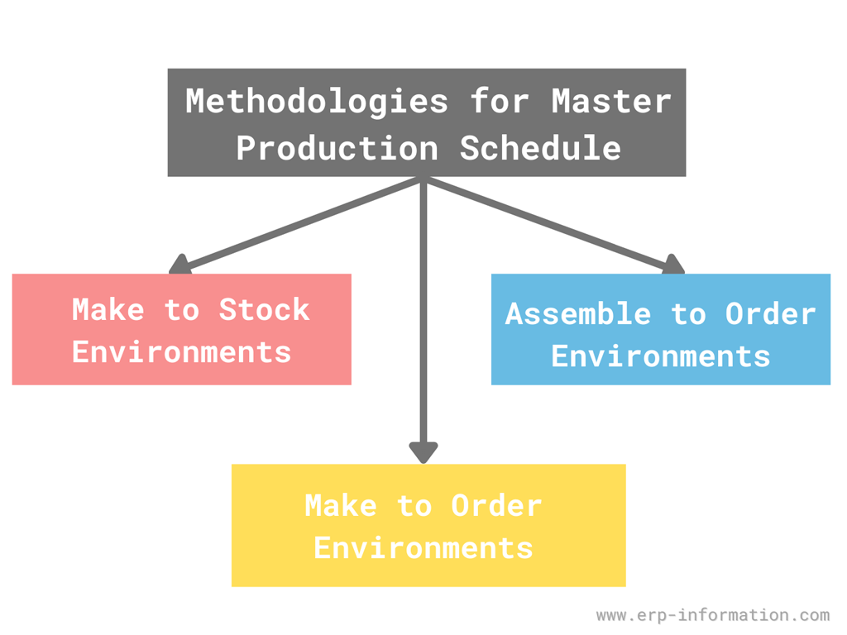

Make to Stock Environments
In this specialized scenario, a minimal quantity of items is assembled to form a more significant number of components.
In this scenario, the Master Production schedule would be the schedule of finishing valuable items.

Make-to-Order or Build-to-Order Environments
In this case, various finishing goods are made from minimal raw materials. One of the great examples of this case is the manufacturing process of automobile vehicles.
The main aim of the Master Production Schedule in the Make-to-Order environment would be the periodic arrangement of the actual customer orders.

Assemble-to-Order Environments
Assemble-to-order environments utilize raw materials to produce subassemblies and the essential components effectively.
These components and sub-assemblies work in harmony to form various finishing goods.
In this specialized environment, the Master Production schedule should emphasize at the subassembly level.
MPS in each of these scenarios emphasize the specific area.

Benefits of Master Production Schedule
- It provides an effective and most reliable communication conduit with the sales team to facilitate the planning process.
- Effectively reduce the time incurred in the manufacturing process throughout the year.
- It acts as an effective barrier against the shortage of raw material and any unexpected mishap.
- Make necessary adjustments to address the fluctuation in demands while reducing the waste properly.
- It smartly managed the cost incurred on manufacturing on behalf of the business owner and made the most precise calculation about the raw material requirements.
- It enhances the overall efficiency in the location of production resources.
- It acts as a foundation to construct, improve, and track the sales forecast.
- It helps the organization’s account department reach income and expenses by providing account statements like profit & loss statements and the balance sheets.
- It helps in the calculation of inventory levels.

Functions of Master Production Scheduling (MPS)
The software system of Master Production Scheduling possesses too many attributes.
Before implementing the system of Master Production Scheduling, it is generally regarded as a good practice to analyze the critical aspects of this computerized system that facilitate production.
Here are the critical functionalities of the Master Production Scheduling software system.

Transforming Plans
This specific portion of the software speculates the amount of material, labor, and specialized equipment required to meet the manufacturing goal.

Provide Alternative Production Routes
The Master Production Scheduling system produces a trial and error schedule that gives an alternative route to accomplish the production.
That would tackle any unexpected mishap that would arise within the completion of production.

Utilization of Available Resources
Master Production Scheduling solution establishes the relationship between the load and utilization for the machinery and equipment deployed in the manufacturing process.
That allows for the best utilization of all the available resources and a more efficient production flow.

Establish Capacity Requirement
The Master Production Scheduling facilitates capacity planning by establishing proper capacity requirements.
Master Production Scheduling facilitates the manufacturers to obtain the proper knowledge about the requirement of capacity.

Aid in Information Processing
MPS determines the best appropriate time for delivery. It consistently coordinates with the various management information systems.

Master Production Schedule Example
Master Production Schedule (MPS) transforms the business plans into the intelligent management of the impact of seasonality, promotion, and fluctuating demand.
Here is a typical real-life example,
A pump manufacturer sells ready-to-made products. To successfully manage the sales, the pump manufacturer needs to assemble these products before shipping them within 48 hours after taking orders.
The time required for the completion of the production process is one day. Although numerous components and subassemblies are still necessary for the successful manufacturing of the pump, these subassemblies and internal components enhance the production time from 2 days to 2 months.
To successfully manufacture a pump within 48 hours, the pump manufacturer must access all the components required to manufacture finishing products.

Seven proven steps for creating great MPS
Step One: Define your product lines and families. Product lines represent different categories of products, while product families represent similar products within a line. You’ll need to define both to create an accurate MPS.
Step Two: Assign lead times to each product line/family. Lead times are the time it takes from when you place an order until you receive the product. You’ll need to know this information to calculate your required throughputs (more on that later).
Step Three: Calculate the required throughput for each product line/family. The required throughput is the number of products you need to produce each day to meet customer demand. This figure can vary depending on your business and production needs, so it’s important to calculate it accurately.
Step Four: Allocate resources to meet the required throughputs. Once you know the throughputs needed for each product line/family, you’ll need to allocate the necessary resources (staff, equipment, etc.) to meet those demands.
Step Five: Identify bottleneck operations and determine the required capacity for each. A bottleneck operation is an area of your production process that’s unable to meet customer demand. You’ll need to identify these areas and determine how much additional capacity you need to meet demand.
Step Six: Create a master schedule. This is where the real work of creating an MPS begins. Using steps one through five information, create a master schedule that shows when the company will produce each product line/family.
Step Seven: Monitor and adjust as needed. As with any plan, your MPS will require regular monitoring and adjustment to ensure that it’s meeting your business needs. Make sure to revisit step six regularly to ensure that your master schedule is up-to-date.

Three tips for creating master production schedule

Create a realistic master production schedule
One of the most important things to keep in mind when creating your master production schedule is to be realistic about the amount of product. Don’t try to cram too many items into your schedule, or you’ll end up overscheduling yourself and running into problems.

Start with your high-priority items
When creating your master production schedule, start by listing the most necessary items for your business. These items should be at the top of your list and given priority treatment.

Break down each task into smaller steps
When creating a master production schedule, it’s important to break each task down into smaller steps so you can better estimate how much time it will take to complete. This will help you ensure that each job is completed on time.

FAQs

How is production planning different from the master production schedule?
Production planning is the phase that comes before the master production schedule. Production planning defines the higher production level and tiny details.
Production planning determines how many products should be produced. But MPS defines and decides the number of products made in a given time interval.

What is meant by master scheduling?
Master scheduling is the process of creating a master production schedule, which is a plan that outlines all of the organization’s production tasks and their associated timeframes.
By following these seven steps, you can create a master production schedule that will help your business run more smoothly and efficiently.

Conclusion
Master Production Schedule is generally regarded as the heart of manufacturing Enterprise Resource Planning because it correlates manufacturing and planning.
The MPS management system has been extensively used as a helpful tool for the most precise calculation of resources required to fulfill production plans.
It helps to identify production bottlenecks and potential problems. -MPS can help with forecasting, capacity planning, inventory management, order fulfillment/production schedule.
With the MPS in place, it is easier for a company to predict demand more accurately, which will reduce on-hand inventories. This also improves customer service since customers are not waiting on products that may be out of stock or unavailable at any given moment.

