All About Vendor Rating Procedure
In this article, we’ll explain what vendor rating is, how it is calculated, and what you should look for when assessing it – in detail.
Contents

Definition 1
Criteria for vendor rating 2
Composite Vendor Rating 4
Composite vendor rating procedure 4
Benefits of vendor assessment 5
Disadvantages of Vendor Rating 5
Supplier evaluation or vendor rating – 8 techniques 6
Types of vendor rating 7
Vendor and supplier selection process 7
Vendor rating example 8
Gartner Vendor Rating 10
What are the drawbacks of having multiple vendors? 11
Types of vendor 11
How do you improve your vendor’s performance? 12
FAQs 14
What are the four factors involved in vendor rating? 14
What is vendor rating, and why is it important? 14
How do we rate the vendor? 14
What is the product vendor meaning? 14
Conclusion 15

Definition
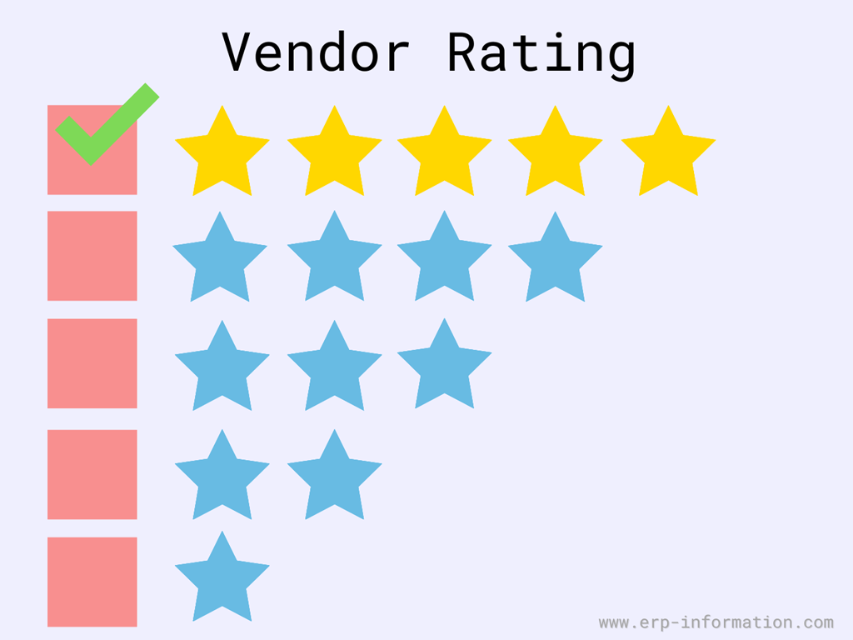
Vendor rating is a process where the suppliers are provided with a status or a title based on several factors.
Factors could be credibility, delivery time, price, quality of the goods supplied, and a set of such mixed variables.
The vendor ratings are based on the vendor’s performance. They can have several levels: good, average to best, or anything that the firm decides.

Criteria for vendor rating
We know that some factors or parameters affect the vendor rating. For example, while evaluating suppliers, buyers usually consider the following things.
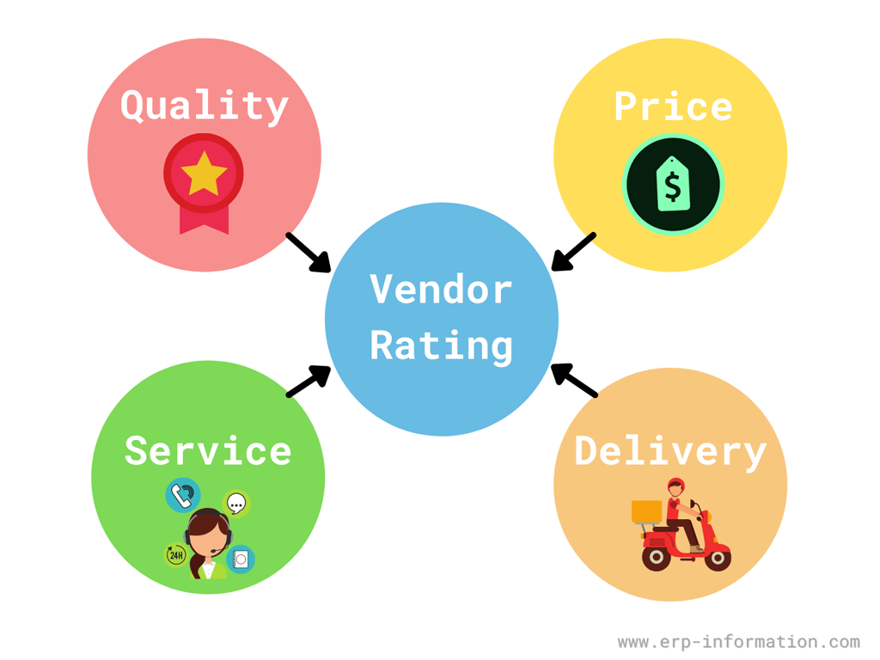
- Quality: The quality of the products or goods vendor supplies is the main factor. The vendor can maintain good quality by improving production, having quality planning in the supply chain. Quality factor consists following things.
  - The supplier should obey and follow the terms and conditions mentioned in the purchase order.
  - The vendor’s products or services must meet the specifications mentioned in the request for proposal and purchase order.
  - The product failure rate should be within the appropriate limit.
  - The vendor should do proper repair or rework.
  - He should provide an adequate time duration for replacement.
- Price: A company always wants to get the materials at less expense to reduce its manufacturing cost to increase its profit. Hence the vendor needs to set a competitive price for his products. It includes the following things.
  - Stable price: The price of the product or service must be stable over some time.
  - Accurate price: There should not be much difference between the purchase order price and invoice price.
  - Prior notice about price changes: He should inform about price changes in advance.
  - Billing: He must provide easily readable and understandable bills.
- Delivery: Supplier has to develop the ability to deliver the goods on a scheduled date. This factor consists following things.
  - Lead time: Lead time is the time between the actual delivery day and order placement day. The shortest lead time helps to get a good impression on the supplier. The vendor should deliver products on or before the promised date.
  - Quantity: He must deliver the correct amount of products as mentioned in the contract.
  - Packing and documentation: Packing of the products must be suitable, study, and undamaged. The vendor should provide proper documents along with the delivered products.
  - Emergency delivery: The vendor must have the ability to deliver products in case of some emergency requirements.
- Service: It is one of the crucial criteria for the supplier. He has to provide good service by providing an updated catalogue, pricing information, technical information along with the following things
  - He must have the ability to handle complaints effectively.
  - The vendor should provide technical support for installation, maintenance, and repair.
  - Emergency support: He should support in the emergency condition of product failure or repair.
  - Resolve the problems: Supplier should find the solution for the problem on time.
The vendor rating system is a by-product of the just-in-time approach.
Just in time (JIT) is a lean manufacturing methodology designed to reduce the waste of time and resources by receiving goods only as they are needed. JIT process was developed in Japan to maximize limited natural resources.
One of the essential objectives of the vendor rating system is that it helps buyers carefully choose the suppliers for future transactions.
The available data can also help to negotiate better and help the buyer with any information that might be useful during the process.

Composite Vendor Rating
Composite vendor rating means rating vendors based on their product price, service, delivery performance, and quality of the product or services.

Composite vendor rating procedure
Following are the four primary rating criteria for composite vendor rating.
- Quality rating: Rate the quality of the product by considering two factors. They are quality acceptance and certification.
  - Quality acceptance means material purchased by the vendor should pass at the first inspection level only. So that we can consider that the quality of the product is good.
  - The material should have some quality certification like ISO(International Organization for Standardization) certification, IRS, ABS, DQA(WP), DQA(N).
- Price rating: Compare the price of the present vendor with other vendors and compare the present price of the material with the average price of the material for a chosen time period.
- Delivery Rating: Rate the delivery performance of the vendor by comparing the actual delivery date with the predetermined delivery date.
- Service rating: Rate the service based on the support provided by the vendor during post and pre-purchase orders and also consider the warranty period.
In this way, do the composite vendor rating by rating all the above factors and choosing the best vendor for your business.

Benefits of vendor assessment
Following are the significant benefits of vendor rating.
- Vendor rating helps the buyer understand the vendor in every critical aspect, and it helps to know if the vendor is suitable to deal with or not. It does not deal with prejudices and word-of-mouth. It is more dependent on data.
- It helps the buyers to strike the right kind of communication required.
- It ensures a consistent standard of vendor performance with updated reviews of their performance.
- It helps the buyer identify areas of weakness in the performance of the vendor and allows the buyer to take corrective actions.

Disadvantages of Vendor Rating
Rating your vendor helps you to enhance your supply chain. But its significant disadvantage is losing trust.
Yes, when you evaluate and rate your vendor, he might feel that you do not trust him.
It may impact your relationship with your vendor/supplier. But practical supplier evaluation helps the supplier to perform well.

Supplier evaluation or vendor rating – 8 techniques
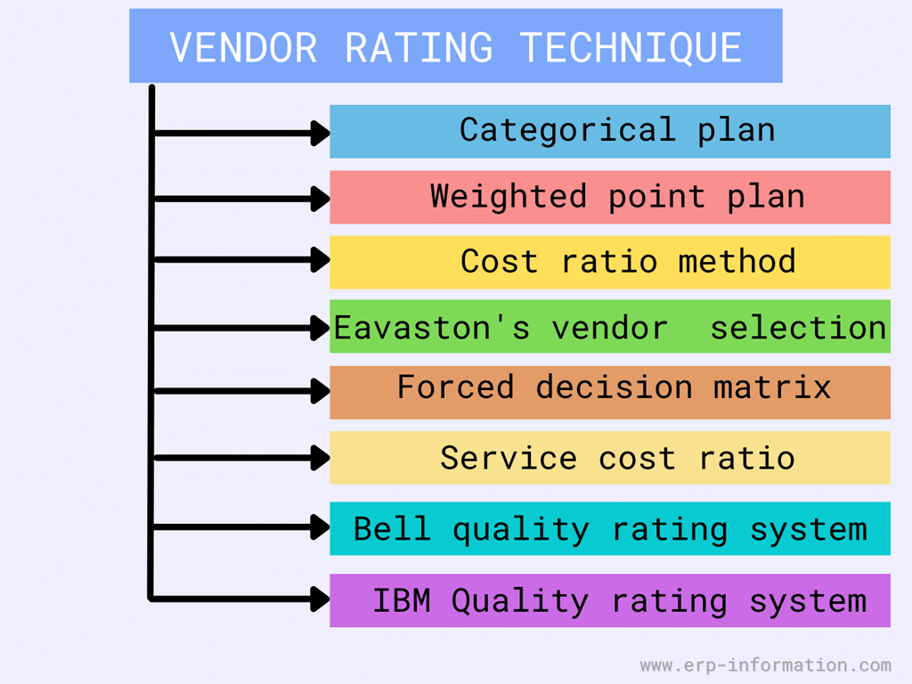
- Categorical plan: managers from various verticals make a list of factors that are crucial for a vendor to own based on their personal experiences, and vendors are compared based on the same.
- Weighted point plan: factors are categorized, and weight is assigned to each factor based on vendor performance. An example is given below for calculating the same.
- Cost ratio plan: Supplier rating is done based on different costs incurred for procuring the materials from different suppliers. The cost ratios are ascertained for the various rating variables such as quality, price, timely delivery. The cost ratio is calculated in percentage based on the total individual cost and the total value of the purchase.
- Eavastons’s vendor selection: previous performances of the vendor are considered for choosing them.
- Forced decision matrix: the attributes of rating like quality, service, price, reliability of the vendor, lead time of supply are identified first. Then these factors are compared between themselves. If something is more important, it will be assigned with one’s weight, and the other will be zero for evaluation.
- Service cost ratio: subjectively measuring other intangible aspects of a supplier’s services. Aspects to consider could be Labour stability, financial stability, flexibility in production for rush orders, research, and development (R&D).
- Bell quality rating system: This is developed by the bell helicopter company, Lot Quality Index(LQI). It assesses lots received against lots rejected. LQI is given by X/L. Where, L = total number of lots received during the period, X = (L1 x 1.00) + (L2 x 2.10) + (L3 x 2.90) + (L4 x 3.10)+ (L5 x 3.90)
  - L1 = Number of lots acceptable as received.
  - L2 = Number of lots rejected by sampling inspection but labeled.
  - L3 = Number of lots rejected and dispositioned, rework at supplier’s end.
  - L4 = Number of lots rejected and dispositioned, returned not usable.
  - L5 = Number of lots rejected and dispositioned rework at Bell helicopter company.
  - This formula can be modified easily to suit the needs of a particular company.
- IBM quality rating system: It uses quality costs as the basis for rating vendors. The formula is VGR= Desired cost of inspection/Actual cost of inspection x 100

Types of vendor rating
Generally, there are three types of supplier evaluation.
- Evaluation with the help of records: In this type, you can use the documents such as financial reports, logbooks, journals to collect information about the supplier. Depending on the result of the evaluation, you can choose a suitable vendor for your business.
- After the event evaluation: Here, you need to find the answer to questions like what happened? how did it happen? how did it fail? This data helps you to evaluate the vendor.
- Before the event evaluation: In this type, collect the historical data of the vendor to find his capabilities.

Vendor and supplier selection process
No matter which business you are running, the vendor plays a vital role in your company. So the question is, how do you select a good vendor or supplier?
You can select a good vendor by evaluating the vendor. Below is the process for vendor evaluation.
- First, set performance criteria for the vendor. Consider the qualities that your vendor needs to have, the vendor’s financial condition, complaint history, quality management system, production process, quality of the product. Based on these things, you can establish the performance of the vendor.
- List out the vendors who meet your criteria. Now choose your vendor from that list by considering the services provided by him.
- Keep on evaluating vendors quarterly/ yearly. Periodically do the audit to monitor the vendor.
- Depending on the resources available, assign a person or a team to evaluate the vendor frequently.
- Consider the type of relationship that the vendor has with you while selecting your vendor or supplier.

Vendor rating example
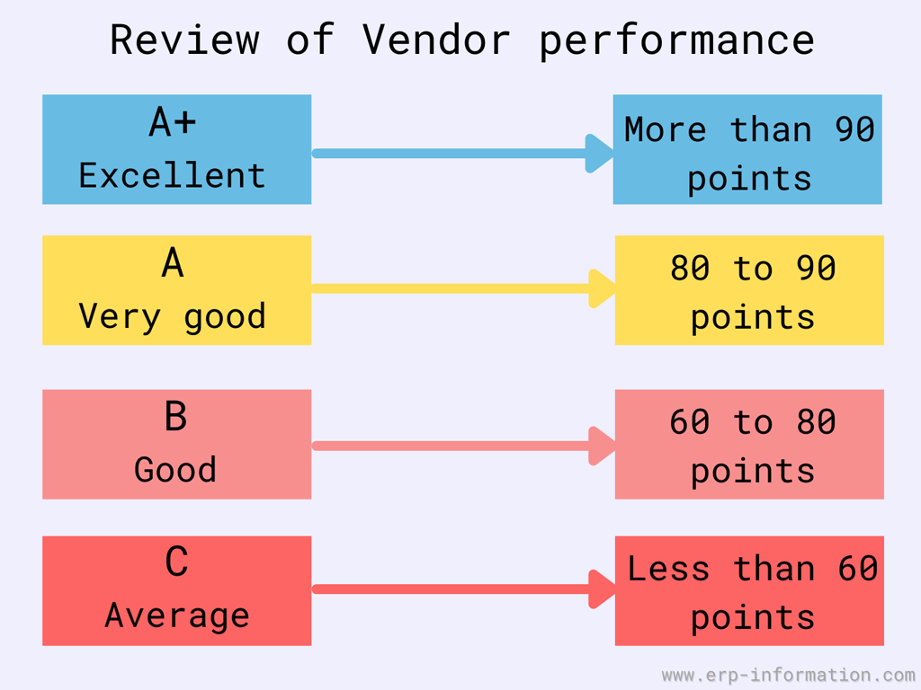
Let us rate two companies, A and B.
Factors considered are quality, price, delivery.
Weights for each of the above factors is
- quality – 60%
- price – 20%
- delivery – 20%
If we multiply each factor’s values by their weights, we can derive ratings and compare which one is better.
Company A inputs:
Total quantity supplied: 10 units, total quantity accepted: 8 units, price per unit: $10, Delay in delivery 20% time delay.
Quality rating = (8/10)X100=80%
Price rating =(10/10)X100=100% [ price rating =(Price Ratio Lowest / Simplier Price) x 100 ]
Delivery rating = 100 – 20= 80%
weighted vendor rating of company A= (80X60+100X20+80X20)=84
Company B inputs:
Total quantity supplied: 20 units, total quantity accepted: 18 units, price per unit: $16, Delay in delivery 10% delay.
Quality rating = (18/20)X100=90%
Price rating =(10/16)X100=62.5% [ price rating =(Price Ratio Lowest / Simpler Price) x 100 ]
Delivery rating = 100 – 10= 90%
weighted supplier rating of company B= (90X60+62.5X20+90X20)=84.5
Though the price per unit of company B is more than company A, company B still wins because of overall rating is high.

Gartner Vendor Rating
Gartner vendor raring is a method that provides the best content to the customer to evaluate vendors or providers for mutual benefits.
It considers the things like
- Product/Service offered by the vendor
- Support provided by the vendor
- The pricing structure of the product or services
- Technology
- Strategy
- Corporate Viability
It rates the vendor from weak to strong.
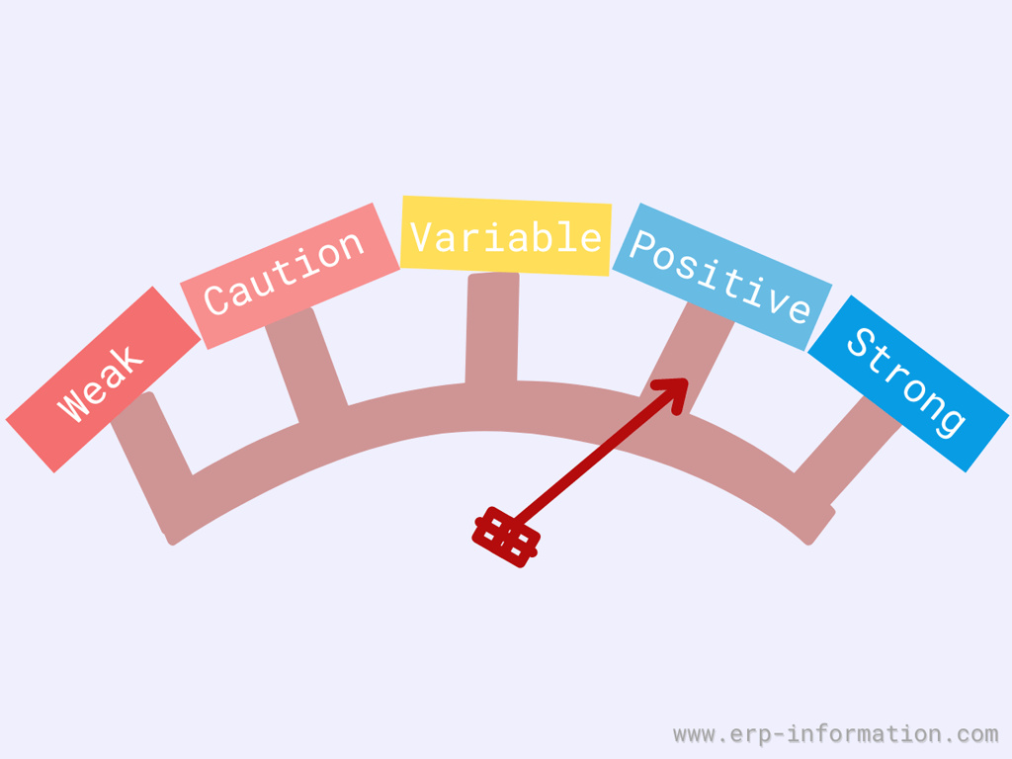
- Strong: Vendors with the best focus, quality products or services, and a good market position will come under this category. The customer feels comfortable and shows interest in continuing the relationship with the vendor. He considers this provider as the best choice for new investments.
- Positive: Vendors with good focus, good quality products/services will come under the positive category. Customers can continue working with vendors for planning investments.
- Variable: Average vendors will come under this category. The customer should consider the maturity of the vendor and the short-term &long-term effects during the relationship.
- Caution: Poor service providers will come under this type. The customer should understand the limitations of the vendor and eventually plans based on risk and future business effects.
- Weak: Vendors with very poor performance will come under this category. Customers should consider this vendor only for planned investment and eventually arrange another vendor.

What are the drawbacks of having multiple vendors?
Vendor rating helps you to select the best vendor. It keeps you away from the problems of having multiple vendors. Some of the drawbacks of having multiple vendors are
- You may face problems while sharing information.
- If you have many vendors, then the order volume will be less. Hence there will be no chance of bargaining.
- It is challenging to have a good relationship with all the suppliers. That leads to less interest by the supplier in your organization, which may affect the responsiveness at the time of emergency.
- Having many vendors consumes more time and money while managing, executing processes, and negotiating contracts.

Types of vendor
To choose a good vendor for your business, check out the type of that vendor in the market. We can differentiate the vendors depending on their experience and dependence that is shown in the below image.
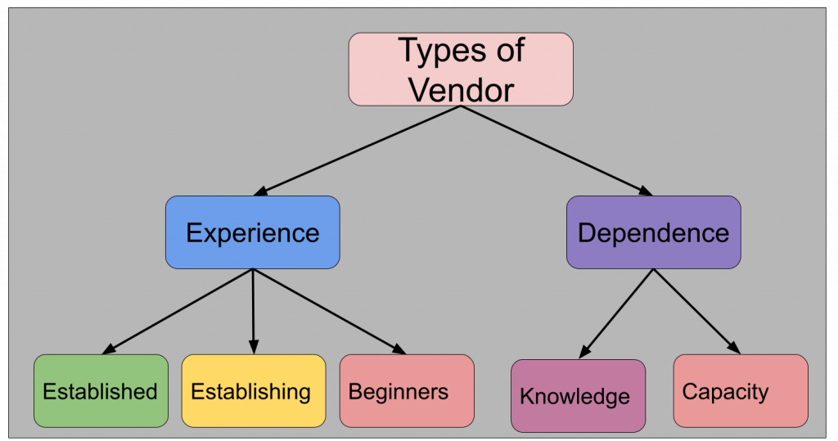
So you need to consider the establishment or experience of the vendor and the knowledge and capacity of the vendor.

How do you improve your vendor’s performance?
Here I will list some tips to encourage and improve your vendor’s performance.
- Make higher management participate in the process: It is an essential step because if you involve higher management then only you can get sufficient resources to execute this process.
- Set a performance measurement: Set key performance indicators(KPIs) and make sure that it should cover the areas like vendor service, vendor response capacity, vendor’s managing skill, and sales support. Let him know that you are monitoring him and reviewing his performance.
- Clearly define your expectations: Clearly communicate with the vendor about what you want and those things he needs to focus on. For example, provide a unique requirements list to each vendor instead of providing a general requirements list to all vendors so that they can easily identify your needs.
- Do a realistic analysis of the supply chain management system: Explore your purchase and supply chain management practices to discover the strengths and weaknesses.
- Have a good team for supplier management: Based on the complexity of the supply chain, have the team members for quality check, logistics, planning, and engineering. In addition, let the team members share supplier management plans and targets so that this team approach helps to boost vendor performance.
- Train your team members: Train the team members about how to approach the vendor, how to make him understand your needs, how to make him reach goals. While training, concentrate on what you want from your vendors and how to approach them to get it.
- Keep a good relationship with your vendor: Analyzing and evaluating the vendor is not sufficient. Instead, have a friendly relationship with him. Visit his place, greet him when he comes to your place. It improves his confidence and performance.

FAQs

What are the four factors involved in vendor rating?
The four factors involved in vendor rating are quantity, price, service, and delivery.
In this economy, most buyers want to buy the largest number of items at the most affordable price with a reliable transport provider who will deliver them quickly without an interruption along their supply chain.

What is vendor rating, and why is it important?
It is the procedure to make better decisions in selecting the most suitable supplier. It is important because it helps make informed decisions rather than an individual’s cognitive biases.

How do we rate the vendor?
We rate the vendor by considering the quality of the product, price of the product, delivery time, lead time, and overall services provided by the vendor.

What is the product vendor meaning?
A product vendor is a business that sells products to other companies. The term “vendor” typically applies to any company, whether they sell physical or digital products. Vendors often provide their customers with branding, marketing, and distribution services in addition to the product itself.

Conclusion
Many supply chain management solutions (SCM) are available with an inventory module that includes vendor rating and evaluation mechanisms.
The system needs to be implemented company-wide to get accuracy in supplier evaluation. In addition, the review should be made only based on measurable performance instead of opinions.
We have provided you with helpful techniques that will help guide your assessment process so you can confidently rate a new supplier or evaluate one of your current suppliers when necessary.

